**FACE MASK DETECTION FOR PUBLIC TRANSPORTATION**

INTRODUCTION:

Covering our faces with a mask has become a new normal amidst the pandemic, as face masks are effective in preventing the virus outbreak. Many developed and underdeveloped nations worldwide have made it compulsory for people to wear masks if leaving home or visiting public places. Other precautionary measures are also advocated by the government to maintain safety and hygiene, apart from shielding faces. On the other hand, it will be challenging to recognize faces with masks on any monitoring systems, while maintaining touchless access control in buildings. Covering faces with masks has posed a challenge for face detection algorithms and performance.

Analyzing the current scenario everyone wants to make sure that everyone working or visiting a public or private place is wearing masks throughout the day. The face mask detection platform can quickly identify the person with a mask, using cameras and analytics. And since most of us commute or go to our workplaces by means of public transportation, it is very essential that we wear a mask and ensure that our fellow commuters to wear one, in order to avoid the transmission of the virus. But it’s not possible to manually keep checking if everyone around is wearing a mask . So we can automate this process by developing a face mask detector which can be used at bus stops , to find out people who do not wear masks and to send their photos to respective authorities to alert them.

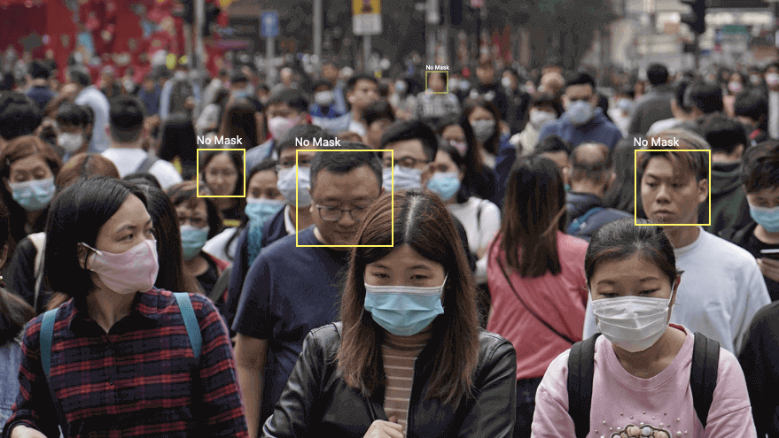

ABOUT WATSON STUDIO:

IBM Watson Studio helps data scientists and analysts prepare data and [build models](https://dataplatform.cloud.ibm.com/docs/content/wsj/getting-started/welcome-main.html?audience=wdp&context=wdp) at scale across any cloud. With its open, flexible multicloud architecture, Watson Studio provides capabilities that empower businesses to simplify enterprise data science and AI, such as:

* Automate AI lifecycle management with [AutoAI](https://dataplatform.cloud.ibm.com/docs/content/wsj/analyze-data/autoai-overview.html)
* Visually prepare and build models with [IBM SPSS Modeler](https://dataplatform.cloud.ibm.com/docs/content/wsd/spss-modeler.html?audience=wdp&context=wdp)
* Build models using images with [IBM Watson Visual Recognition](https://www.ibm.com/cloud/watson-visual-recognition) and texts with [IBM Watson Natural Language Classifier](https://www.ibm.com/cloud/watson-natural-language-classifier)
* Deploy and run models through one-click integration with [IBM Watson Machine Learning](https://www.ibm.com/cloud/machine-learning)
* Manage and monitor models through integration with [IBM Watson OpenScale](https://www.ibm.com/cloud/watson-openscale)

We will be using the Watson Studio in order to train our images (pictures with and without masks) and provide the results.

ABOUT WATSON VISUAL RECOGNITION:

The IBM Watson Visual Recognition service uses deep learning algorithms to analyze images for scenes, objects, and other content. IBM Watson Studio provides a collaborative environment in the cloud where you can work with your images and your Visual Recognition custom models.

ABOUT PREDICTOR:

The predictor that we have been designed can be used to provide entry into the public transport automobiles only to those commutators who wear mask. The predictor can be attached to a videocam to take real time images and provide or not provide access for the commutator to avail the transport service.